SQL Query Assignment – I

1. Find out the PG-13 rated comedy movies. DO NOT use the film_list table.
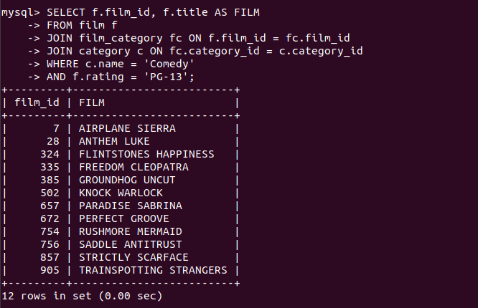

2. Find out the top 3 rented horror movies.

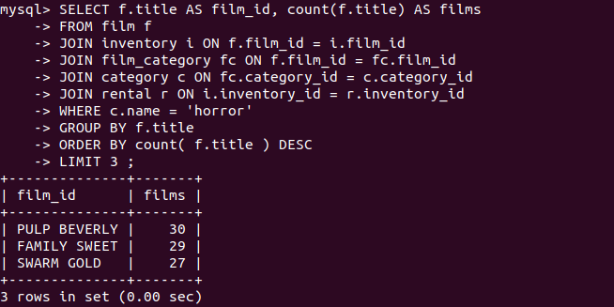

3. Find out the list of customers from India who have rented sports movies.




4. Find out the list of customers from Canada who have rented “NICK WAHLBERG” movies.

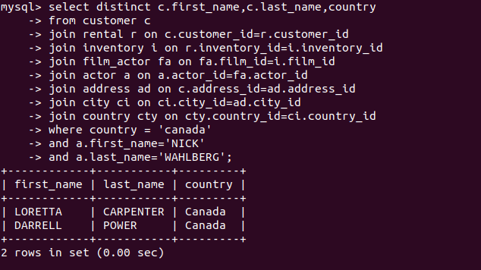

5.Find out the number of movies in which “SEAN WILLIAMS” acted.



